Project Design Phase
Solution Architecture
Date
Team ID
Project Name | Automated Network Request Management in ServiceNow
Maximum Marks | 4 Marks
Solution Architecture:
Solution architecture is a complex process — with many sub-processes — that bridges the gap between business problems and technology solutions. Its goals are to:
- Find the best technology solution to solve the existing network change request problem.
- Describe the structure, characteristics, behavior, and other aspects of the ServiceNow solution to project stakeholders.
- Define features, development phases, and solution requirements.
- Provide specifications according to which the solution is defined, managed, and delivered.

Proposed Architecture Overview
The solution is architected natively on the ServiceNow platform, spanning four functional layers: a self-service intake layer, a workflow and validation layer, an orchestration and fulfillment layer, and an audit / reporting layer. Together these layers automate the full lifecycle of a network change request — from submission to audit-ready closure — while keeping the CMDB continuously synchronized with the real network state.
Solution Architecture Diagram:
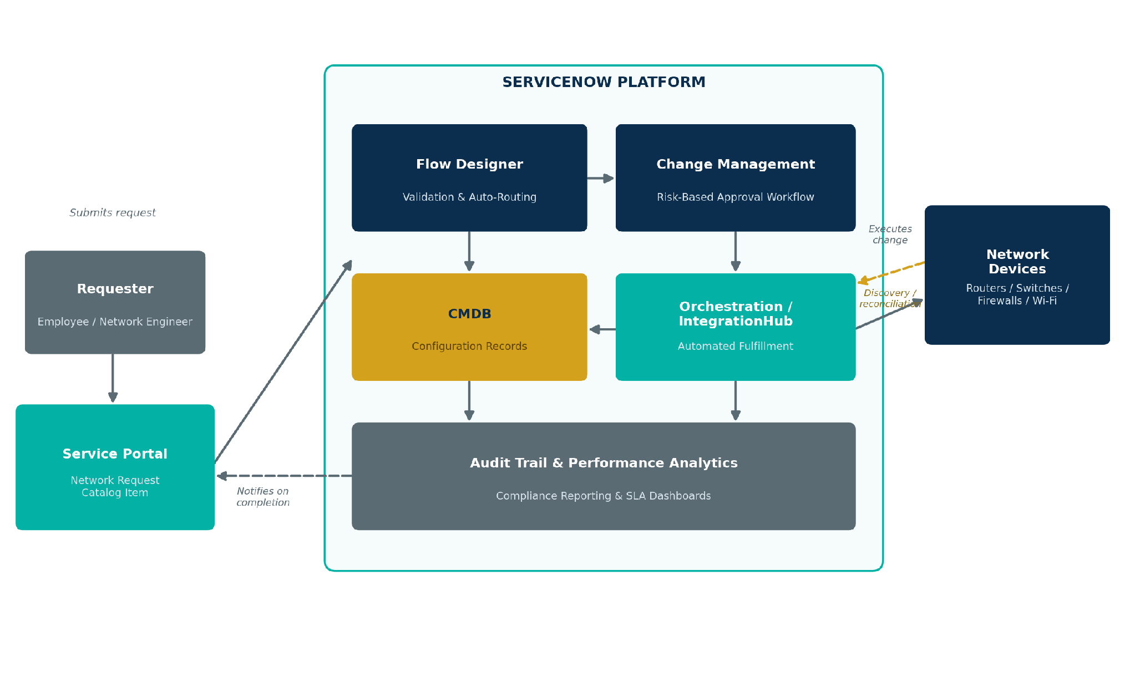
Figure 1: Solution architecture and data flow of the Automated Network Request Management application

Architecture Walkthrough
- Requesters submit a network change request through the ServiceNow Service Portal using a guided Network Request catalog item.
- Flow Designer automatically validates the request (mandatory fields, duplicate check, CMDB correlation) and classifies it by network domain.
- The validated request is routed into ServiceNow Change Management, which drives a risk-based, automated approval workflow with the appropriate approvers or CAB.
- Once approved, Orchestration / IntegrationHub triggers automated fulfillment, executing the configuration change on the relevant network devices.
- The CMDB is automatically updated with the new configuration state, and discovery/reconciliation confirms the change matches the live network.
- An audit-ready change record is generated automatically, and the requester is notified of completion; performance analytics dashboards capture SLA and compliance metrics.

